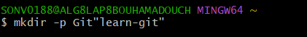

creating a new folder

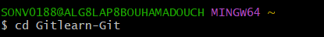
change directory into learn_git folder

initialize an empty git repository

creating a file called third.txt

adding third.txt to the staging area

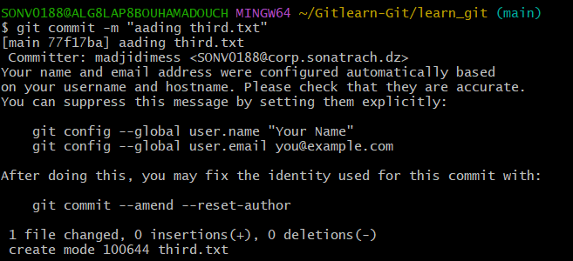
commit adding third txt
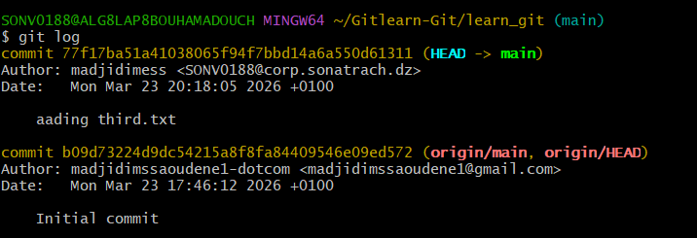
check my commit with git log
adding a new file fourth.txt

adding fourth to the staging area

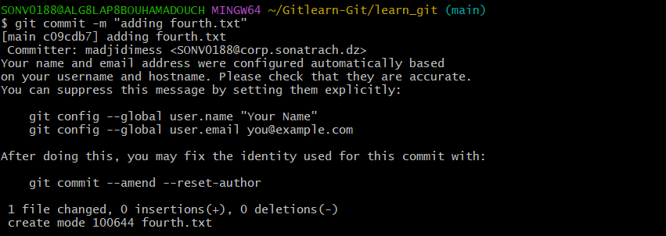
commit with adding fourth.txt

removing third.txt

adding change to staging area

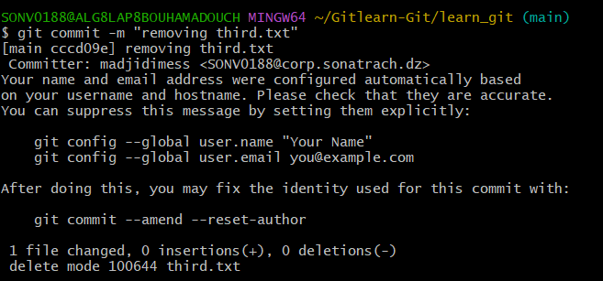
commit with the message removing third.txt

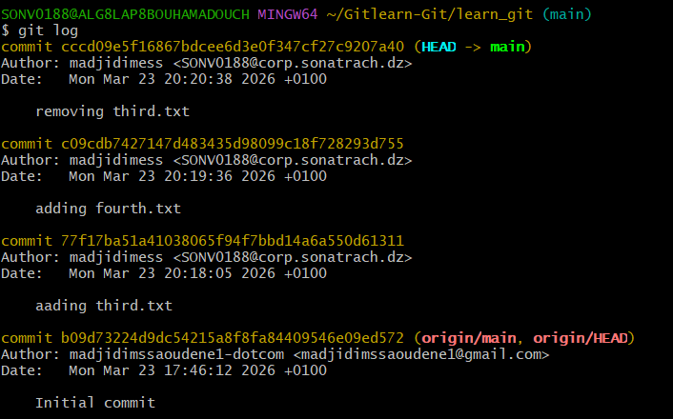
check commits with git log

change global settings

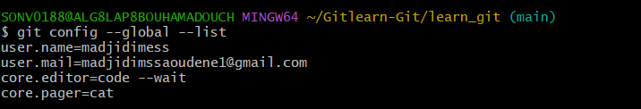

list all the global configurations for git on my machine

